Mini TDD - TIPS 4337 Bundler
Chris Hunter
Oct 30, 2025

Overview

TIPS Bundler
ERC-4337 bundlers have the job of including user operations (smart account transactions) onchain. There is currently a large group of providers [CDP, Alchemy, Pimlico, Biconomy, Zerodev …] which developers choose from.
This proposal is to build a native bundler within the Base Transaction Inclusion and Priority Stack (TIPS) which will enable the best speed and cost for user operations and include support for auditing traces via the TIPS UI.
Relevant doc: Account Abstraction Issues

High Level Architecture

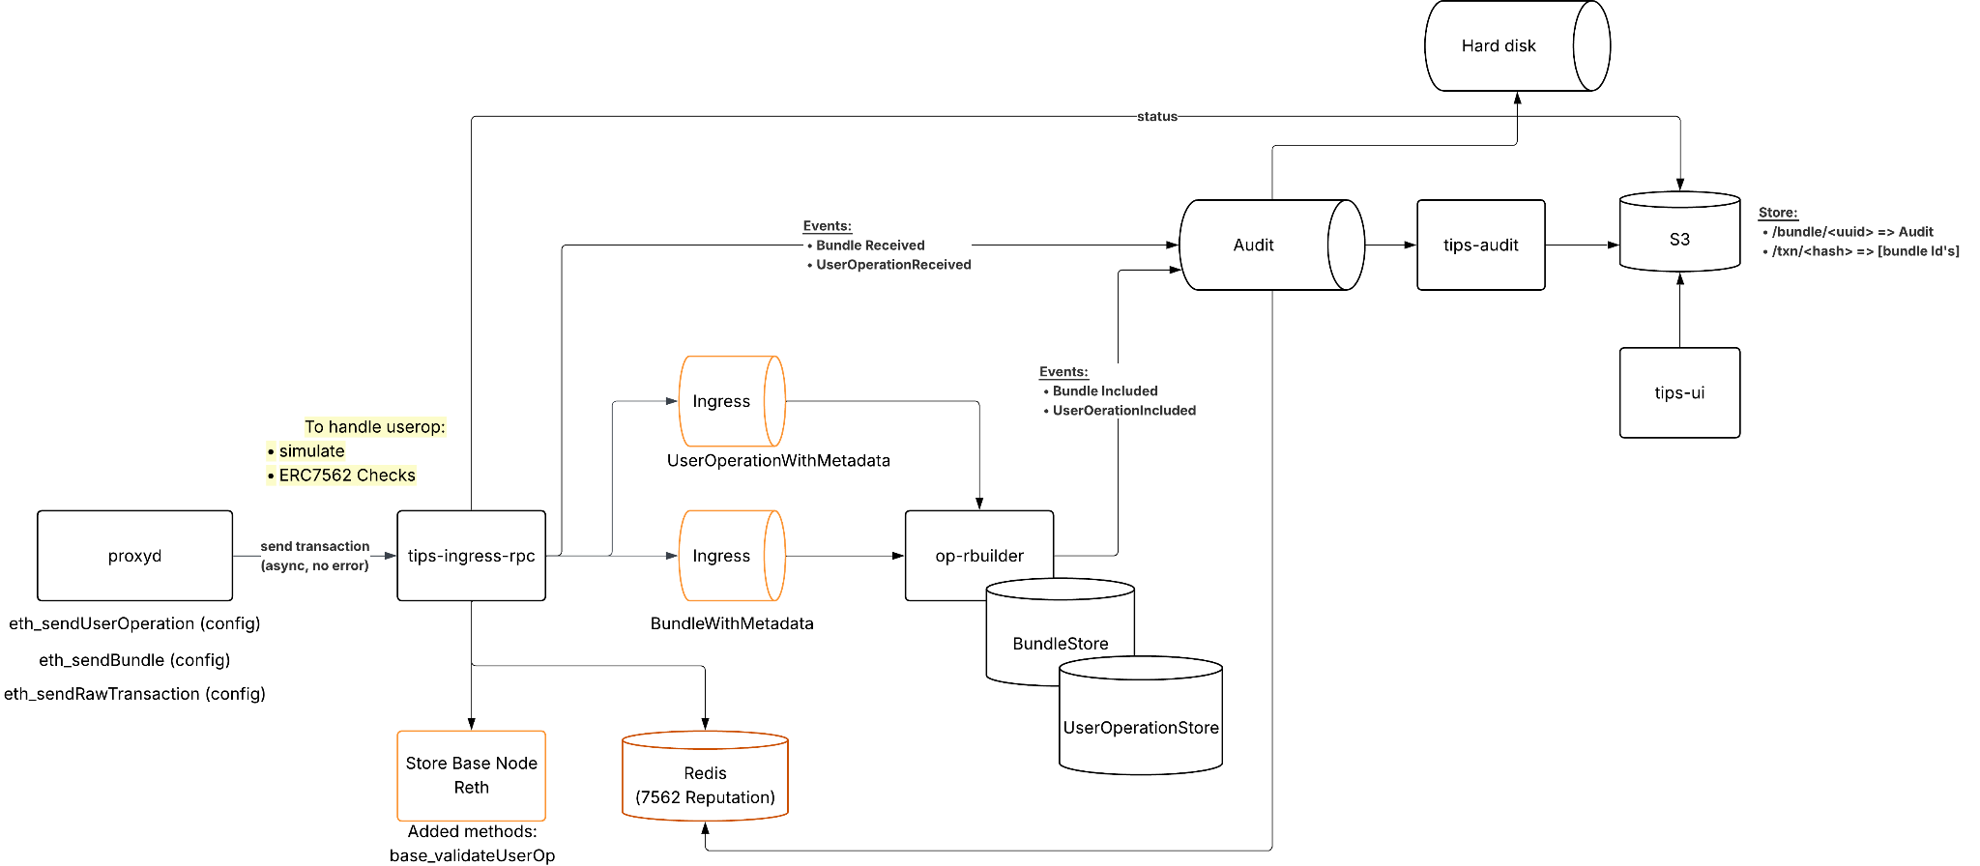

Ingress
TIPS will expose eth_sendUserOperation bundler RPC and perform the standard ERC 7562 checks while operating the user operation mempool. Support for the standard v0.6 through to the upcoming v0.9 entry points will be enabled. Base node reth will also include base_validateUserOperation which will be used by the send endpoint to validate the user op before including it in the user operation queue and standard 4337 bundler methods outlined later.
ERC 7562
Account Abstraction Validation Scope Rules specified in ERC 7562 is used to protect bundlers from DoS attacks through unpaid computation and reverting transactions. These rules define validation rules by restricting opcodes, reputation, storage access, bundle rules and potentially staking globally used contracts (ie. paymasters and factories).
These restrictions minimize cross transactional dependencies to mitigate the risk that any transaction could invalidate any other transaction (ie. flip a boolean in the wallet to reject validation) and so the mempool and bundle builder must run it in order to stay protected.
In order to run 7562 in TIPS we will need to stream events from the block builder (which would be included in the TIPS audit stream) to update the rules for ingress and use it for reputation/mempool limits. An example here is that a caller may become rejected due to a malicious paymaster that was banned. Note that this entity information includes opsSeen and opsIncluded and should be persisted across deployments.
We will maintain a simple redis cluster that offers the reputation scores of relevant entities of a userOperation. This includes sender, paymaster and factory. This simply tracks opsSeen and opsIncluded over the time configured interval. The service will filter out any user operations that are valid but whose reputation state is BANNED, prior to validation check via base_validateUserOperation ensuring only allowed operations pass through while throttled or OK users continue to be processed.

Block Building
Having the bundler within the block building process also means:
- We can make as large of bundles as we want to which can reduce the number of signatures down from worst case 2N to best case N+1 (where N is no. user ops). This is a major benefit for data availability usage on Base Chain and will improve chain scaling bottlenecks.
- We could offer priority fee ordering on user operations against EOA tx.
These two items are slightly in conflict. A user operation currently requires an EOA bundle tx to be submitted, so to offer ordering interwoven with standard EOA txns there would need to be more bundle tx, increasing the number of “wasted” signatures.
The initial proposal is to do one large bundle at the middle of each flashblock with userop priority fee ordering within that bundle. Later if we add a new tx type designed for bundle submitting then we can interweave them without any impact.
The 4337 bundle will be built by incrementally stacking userOp validation phases and then attempt to include the transaction. Any reverting ops within the bundle will cause the tx to revert. They would be pruned and resubmitted. Stacking validation phases in the previous step would minimize this risk.

When a bundle tx is submitted, all useroperation validations happen prior to any execution phases of the user operations. Therefore incrementally building a bundle means stacking validation phases. The execution phase can be done once for the whole bundle once built (no revert risk).
Key management
The block builder’s native 4337 will initially require a hot bundler key that will need to be managed, it is likely to accrue ETH (bundle bear has bundler profit in the millions) - this balance should be swept periodically (ie every N blocks) with a cheap send tx to whatever address we choose (sequencer?).
Eventually as part 2/3 of AA V2, we will add a new transaction type to remove this hot key and further optimize compression. In this case the beneficiary of the bundle is set to the sequencer address (coinbase).

Endpoints
User operations require specialized estimation endpoints, provided by the RPC eth_estimateUserOperationGas. This returns gas limits for verification, execution, and preverificationGas (PVG). Preverification gas is paid in full to the bundler and is designed to include the bundler tip, entrypoint overhead gas and the L1 data fee. Typically bundlers will not submit if PVG is too low, and there are differences in computation of the PVG across bundler implementations.

This means we need to standardize the PVG calculation to ensure requests passed to eth_sendUserOperation on are accepted.
This calculation should be well documented and offered in Base nodes via eth_estimateUserOperationGas. Clear and standardized PVG too low error messages should allow developers to easily update when they choose to use the TIPS pipeline.
We will add all the eth_ 4337 methods to Base nodes such that they do not require additional infrastructure to use. A big advantage here is that this means users can get estimates using nodes that are closest to them rather than routing to their bundler in a specific location (ie US East 1 AWS)
The following are added to base/node-reth
Method | Details
base_validateUserOperation | Validates the userOperation conforms to 7562 and has a successful validation phase.
eth_supportedEntrypoints | Returns the entrypoints supported by the native TIPS bundler
eth_estimateUserOperationGas | Returns the estimate for PVG, gas limits (same calculation as used by the TIPS native bundler to accept an op)
eth_sendUserOperation | Sends the userOperation to the tips pipeline after initially validating tx.
eth_getUserOperationByHash | Gets the userOperation by hash (flashblock enabled)  - Note that this API can return partial data if the node is aware of a userOperation but it is not yet included (equivalent to looking into the mempool), we can integrate with TIPS or use p2p for relaying to TIPS to share the AA mempool to enable this
eth_getUserOperationReceipt | Gets the userOperation receipt (flashblock enabled)  Need to decide on indexing here:  - add new table with userOpHash -> tx hash + op index (past N blocks?)

Call Flow
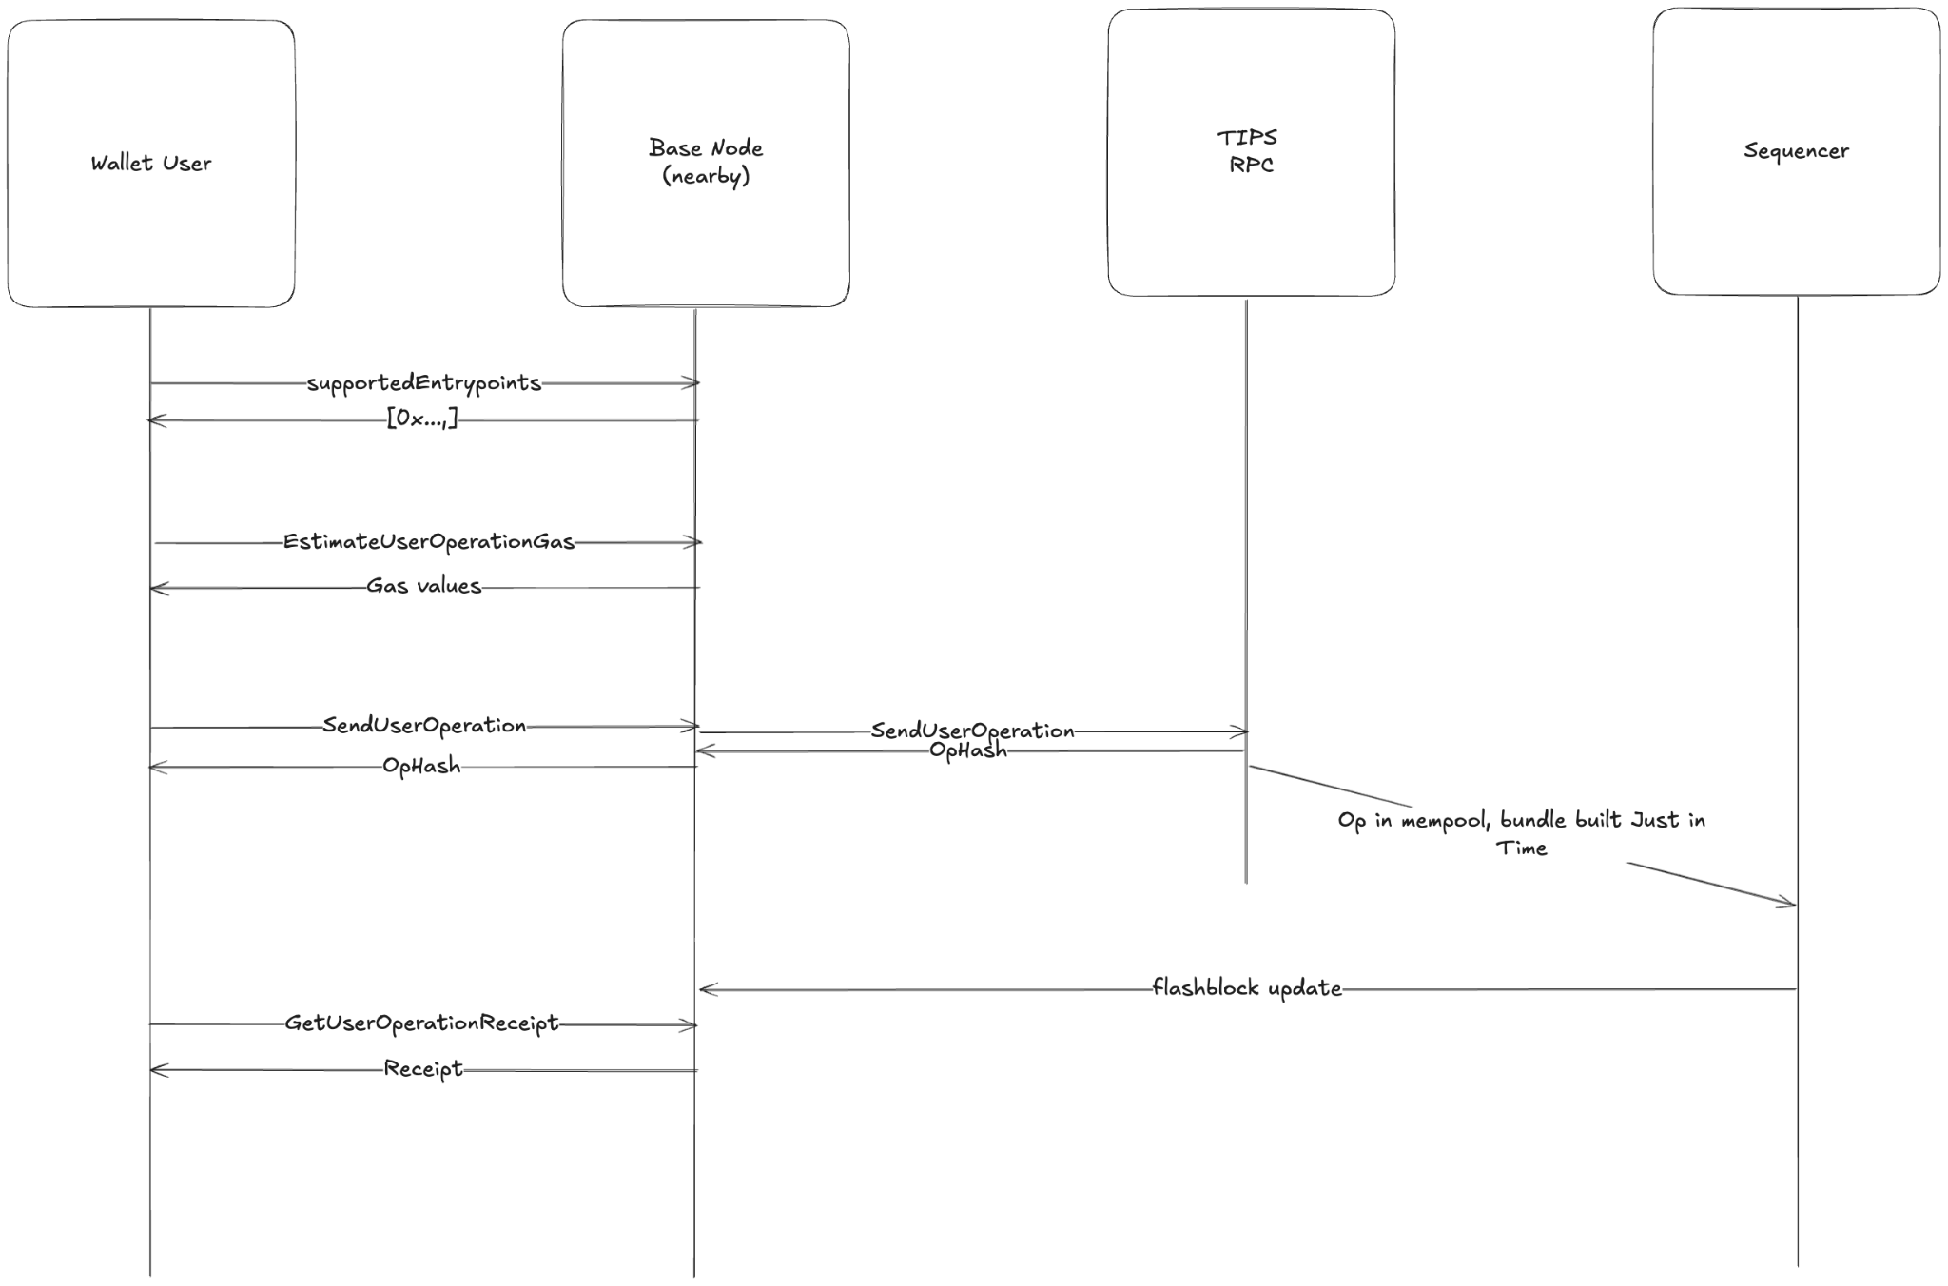
Note that wallets are likely expected to expose EIP 5792 and so wallet providers would be the ones expected to integrate here.
PVG
PreverificationGas has 2 issues:
- The primary source of overcharging
- Userops can sit in mempool if PVG is too low to be included by bundler profitably

To resolve overcharging, we need to decouple the L1 data fee from the bundlerTip + entrypoint overhead which would need an entrypoint contract change (part of AAv2 part 2). This will enable us to have a l1GasFeeLimit rather than a fully charged PVG. Outside of contract/protocol changes, base can offer lower pvg values as more traffic comes through the native TIPS bundler as costs can be amortized across userops in a bundle. Current bundler implementations all assume 1 userOp per bundle (because they can't be sure how many ops there will be at ingestion) and large spikes in L1 gas fees cause high PVG estimation values.
To resolve stuck userops, the limit allows devs to not worry about putting too high a PVG value and risk overcharging. Developers can add specific buffers to guarantee inclusion in next X blocks.

Questions
- DA Throttling Behaviour
- Failover

Other Implications

- Bundler providers will have profit drop on Base, though they can still operate bundlers and paymasters for their clients.
- CDP bundler RPC can provide access to TIPS

Task List

What | Effort | Notes | Status
Add base_validateUserOperation to base node reth | 3 days | Used to validate userOperations | In progress Chris Hunter
Add bundler rpc methods to base node reth | 2 weeks | eth_getSupportedEntrypoints  eth_estimateUserOperationGas  eth_getUserOperationReceipt  eth_getUserOperationByHash  eth_sendUseroperation | In progress Chris Hunter
Add eth_sendUserOperation endpoint to tips ingress | 2 days | First iteration calls base_validationUserOperation. Later needs to integrate with 7562 check.
Add queue for userOperations | 3 days | Kafka to mempool / rbuilder
Add userOperation mempool | 2 weeks | Fetch best ops.  Needs to allow quick invalidations
Add rBuilder support for userOperations (bundler) | 1-2 weeks | Hot key bundler. Submit validation userOps and
Add userOp audit pipeline | 1 week
Add 7562 support:  - redis for reputation scoring  - traces for validation rules | 2 week | Requires reputation system and base node reth to provide 7562 info via debug_traceCall. See this PR for the native tracer. Note rundler has its own implementation but we should use the new one from EF linked.  https://github.com/paradigmxyz/reth/issues/19085

